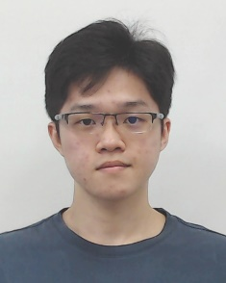**FOCS_StudF03: Student’s Progress Report**

Attached a photo here

(use digital photo)

**Tunku Abdul Rahman University College**

**Faculty of Computing and Information Technology**

**Industrial Training Progress Report**

Activity Log

|  |  |
| --- | --- |
| Name of Trainee: | Kong Mun Jun |
| Name of Company: | Ezee Technosys (M) Sdn Bhd |
| Month/Year: | March / 2022 |

|  |  |
| --- | --- |
| **Week** | **Projects / Activities** |
| **1** | Did some case study and researches with the system. Then, all intern undergo few assessment of every product to determine whether we familiarise each of the company product. Product that include in assessment are On Premise Hotel Management System - eZee FrontDesk, Cloud based Hotel Management System - eZee Absolute, Channel Manager - eZee Centrix, On Premise Point of Sales System - eZee BurrP! and Cloud based Point of Sales System - eZee Optimus. |
| **2** | After company supervisor had reviewed our assessment, they had a small session interview to understand our personality to ease them with distributing us into each teams.  I was arranged into Project Implementer Team and given the role of training hotelier using our system and assist them in configuring their management in the system. I had learn how to create hotel account for each hotelier in our system as the first lesson.  At the end of the week, our company having office shifting to the new block with better and wider room layout. |
| **3** | Some of the intern still need to do some clean up in the beginning of the week. However, I was assign with few tasks and need not to do clean up but working from home to complete the given task.  After the company had settle everything, we start with various training such as how to solve customer issues, how to guide them, configure their hotel information for them, and syncing Online Traveling Agent [OTA] (Agoda, Booking.com, …etc) with our system which known as the OTA Mapping. |
| **4** | Handle a lot hotelier messages via Whatsapp and getting updates from ZOHO project platform to receive updated information of new hotel and assist them with configuring their owned system. Did some OTA mapping for various hotel as well.  At the end of the day, our company organise an opening dinner party to celebrate the grand opening. |



|  |  |
| --- | --- |
| **5** | Handle a lot hotelier messages via Whatsapp and getting updates from ZOHO project platform to receive updated information of new hotel and assist them with configuring their owned system. Did some OTA mapping for various hotel as well.  Our company supervisor, Gaka, aslo gave us an assignment which are to prepare a demo training session about hotel management system and present to them. Hence, they could familiar with our training style and give us some wisdom advice. Prepared some presentation slides, arranged the training flow and a little training by alone to get prepare for the assignment. |

**Suggestions / Comments / Additional information (if any):**



**Leave Application / Leave Taken**

1.From (dd/mm/yyyy) ___10/03/2022___ to (dd/mm/yyyy) ____10/03/2022__ ( __½__ days)

2. Reasons for taking leave: Vaccine Booster

3. Total number of days taken:___Half Day__________________________________________

**I hereby declare that the information given above is correct.**

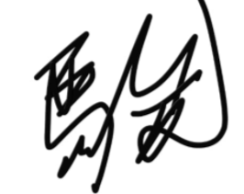

**Signature**: _____________________ **Date**: ___30/03/2021__

*(dd/mm/yyyy)*



|  |  |  |  |
| --- | --- | --- | --- |
| **Endorsement by the Company Supervisor:** | | | |
| **The above is a true record of activities taken by the trainee in the captioned week.** | | | |
| Signature of Supervisor: | __________________________ | | |
| Name of Supervisor: | __________________________ |  |  |
| Date: | *(dd/mm/yyyy)*_______________ |  |  |
| Email: | __________________________ |  |  |
| Mobile / Office Contact No.: | __________________________ |  |  |
| Company Stamp: | Company stamp with address |  |  |

